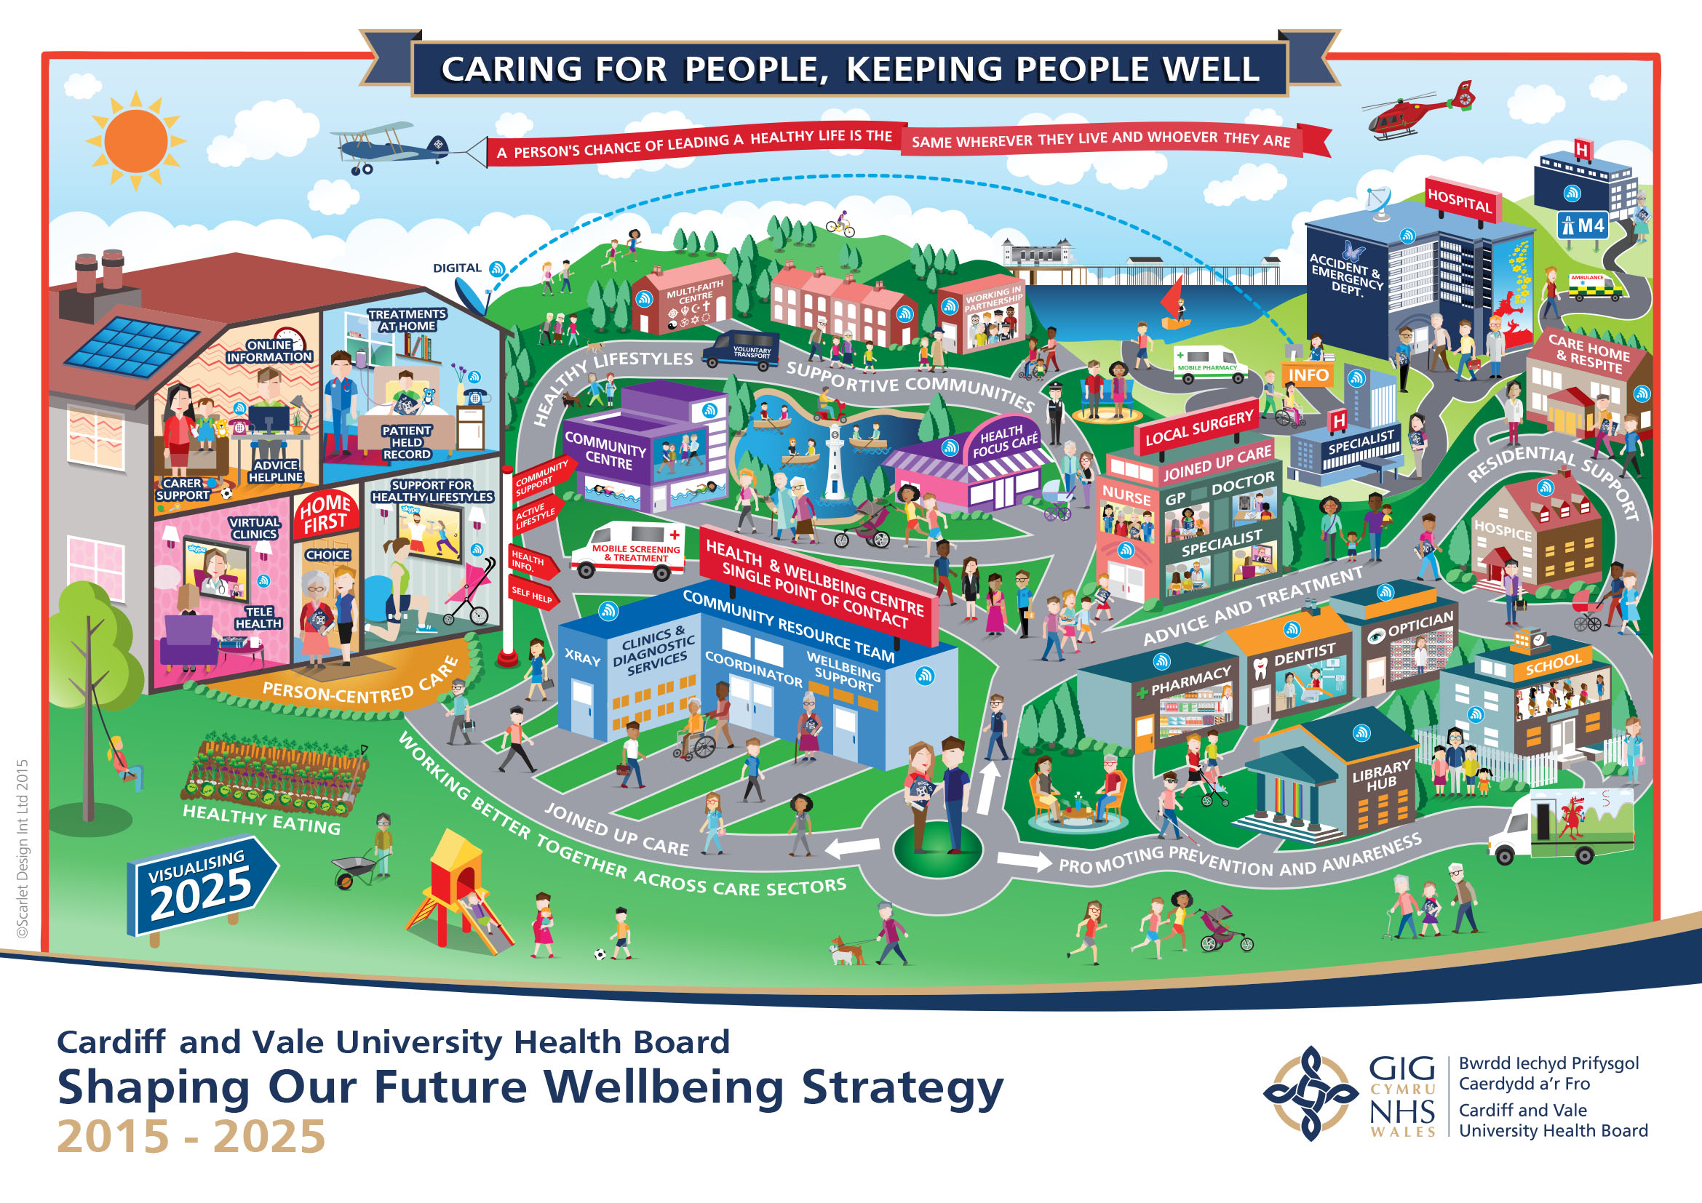

Cardiff and Vale University Health Board is working with citizens, patients and partners to make it a reality that a person’s chance of leading a healthy life is the same wherever they live and whoever they are.

We are looking to create a new Wellbeing Hub@ Park View. During the March and April we met some of you and asked three questions. Here is a summary of your responses.
Question 1. What would you like to see in the new Hub?

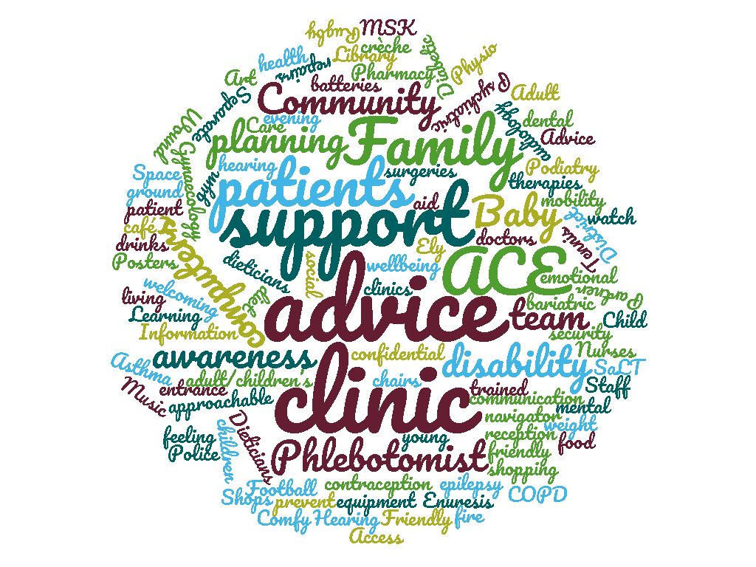
Question 2. How do you think we should plan the outside space?
Car parking (lots) - Security CCTV and lighting – Landscaping - Seating - Clear information and signposting for people with disabilities/ literacy difficulties - Separate outdoor spaces - All ground level and ramps available (plus lifts) – Playground – Child friendly - Community gardens - Gardening club - Litter picking teams - No smoking - Colourful plants and flowers - A sensory garden – Good broadband access – Bike/Mobility scooter/shopping trolley park/shed – Walking groups start point

Question 3. What do you think is important in the design of a new Wellbeing Hub?
Car parking (more and larger spaces) - Bright and welcoming - Language facilities - Non institutional design - Access for people with disability - Staff and patient safety- Keep it clean and tidy - Friendly staff (smiling) - Windows that open or air conditioning - Heating that can be controlled in each room - Security based on site - Good signage- Good storage space with individual keys for regular users - Natural lighting - Clocks (to tell the time) - Things to do - Community feel - A sense of space in the centre - Interesting art work on the walls and shelves, done by local people, including people accessing art for wellbeing session in the hub - Simple main reception so clear where to go – Café (with disabled workers) - Community rooms /space – Designed-in privacy spaces - Exercise room/ community room – Lifts - Accessible toileting facilities to include “changing places” toilets - Improve advertising of services provided – Payphone - Make it easier to communicate - Ticket system (Don’t want names to be called) - Good use of colour – Age group mix of cultures – Back up provision – Outside views – Flexibility – Zoned areas –– Encourage independence – Information sharing directory points – Therapy classes - To reflect the values and ambition of Shaping Our Future Wellbeing

