Shaping Our Future Wellbeing:
In Our Community

Partnership Planning Event
Cardiff Royal Infirmary

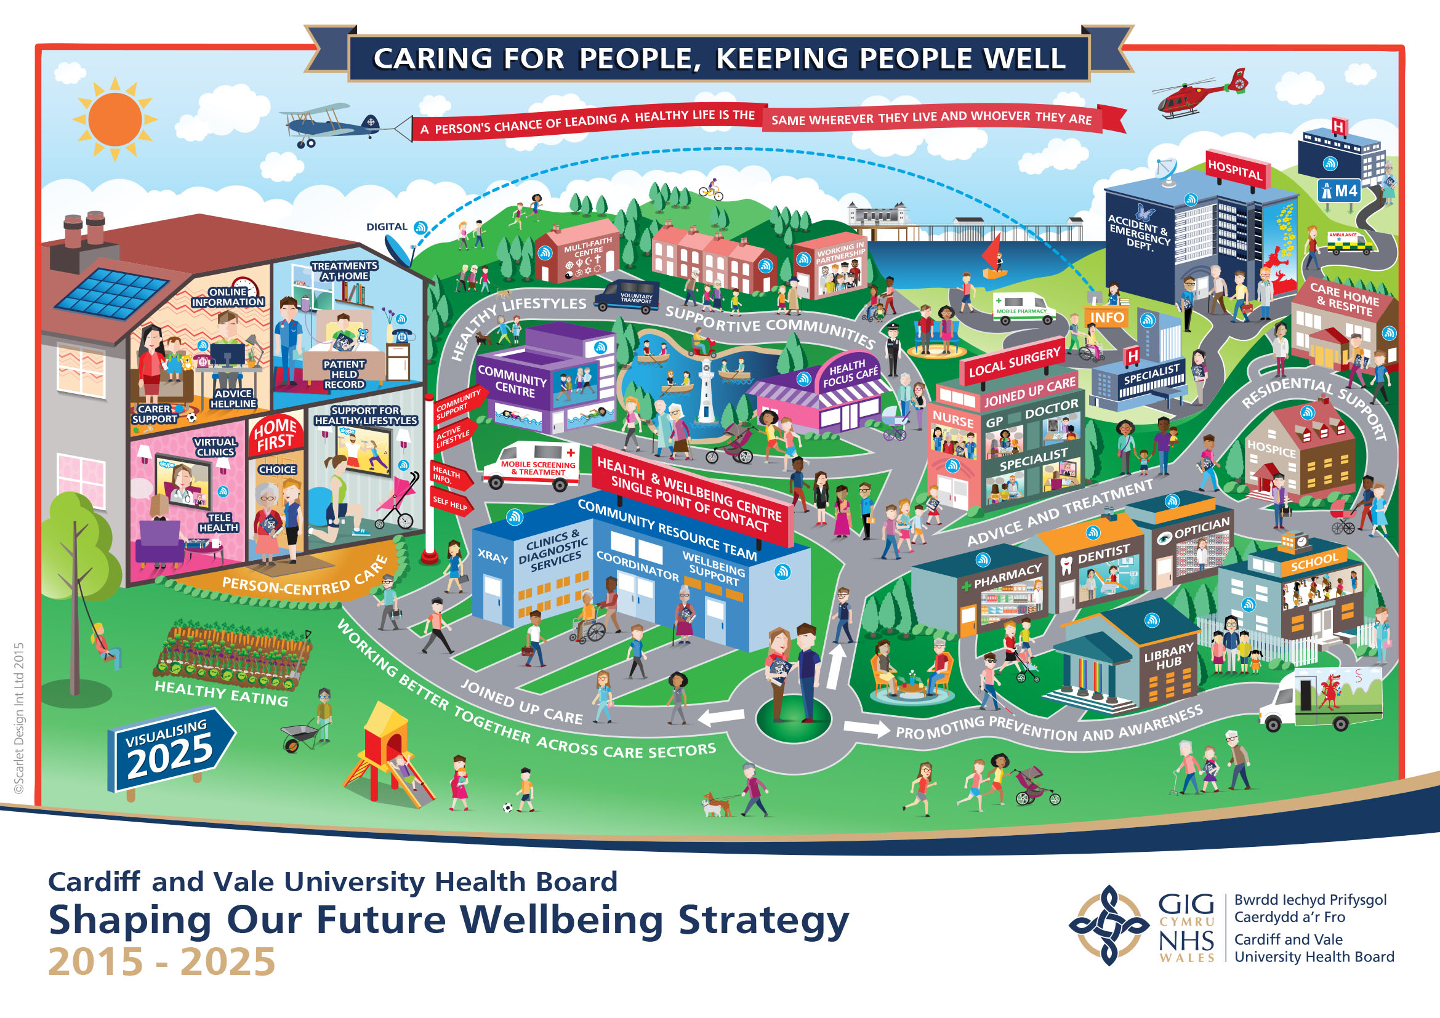

29 March 2017
Feedback report
Shaping Our Future Wellbeing
Cardiff South & East Cluster

1 Introduction
By Karen Elcock and Dr David Meades.

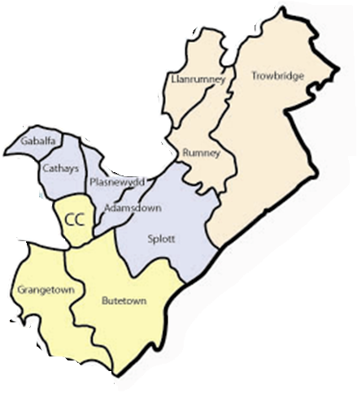
South and East Cardiff is a unique locality with a strong presence of both students and deprivation. It has some nursing homes but with one of the largest student population in a UK city it has a younger than average population. The people have diverse ethnicity and with over 100 languages spoken it can be a barrier to healthcare. The poor access to health care, coupled with high deprivation indices and a low screening rate, contribute to an average life expectancy 12 years shorter than the best and an expectation to live in good health for 22 fewer years than those
in less deprived parts of Wales. Generally there are fewer people with Long Term Conditions but the large student population brings other demands including a wide range of Mental Health issues.
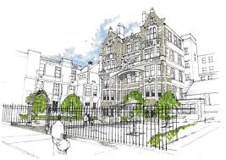
The CRI is the current centre of health care services for the local population of 153,000. The services provided from the building include Cardiff Health Access Practice (CHAP), an initial public health and general healthcare screening service for newly arrived asylum seekers. Cardiff is one of the UK’s six centres for asylum seekers. The CRI also delivers services to two gypsy sites; the management and administration base for Primary, Community and Intermediate Care Clinical Board; the Cardiff South and East Locality Management Team and District Nursing and Health Visiting Teams.

This event is intended to inform the development of the Health and Wellbeing Centre for Cardiff South & East by asking the following three questions.




1b. What are the key health and wellbeing services required to meet the priority needs of the people of the South East Locality?

1a. What is the Vision for the Locality Health and Wellbeing Centre?



2. Where are the services best and most efficiently delivered?

2 The Strategic Context
By Clare Williams, Corporate Strategic Planning Lead.

2.1 Principles
In September 2015, Cardiff & Vale University Health Board (UHB) launched its ten-year strategy, Shaping Our Future Wellbeing (SOFW). The strategy describes achieving joined up care based on the four principles below.

Care at home and in the community is central to our planning.

Key to the implementation of the strategy is the Shaping Our Future Wellbeing: In Our Community Programme. Through a series of community facilities the programme will provide the major physical infrastructure required to support improved access to health and wellbeing services, promoting local integrated working and co-production, with the ultimate aim to reduce health inequalities.

2.2 Geography and terminology
Within Cardiff and Vale of Glamorgan we have three Localities. Each Locality has three Primary Care/GP Clusters. (Local Authorities and partners work within “neighbourhoods” which are geographically the same as Clusters)

Cardiff North Cluster
Cardiff West Cluster
Cardiff North & West Locality

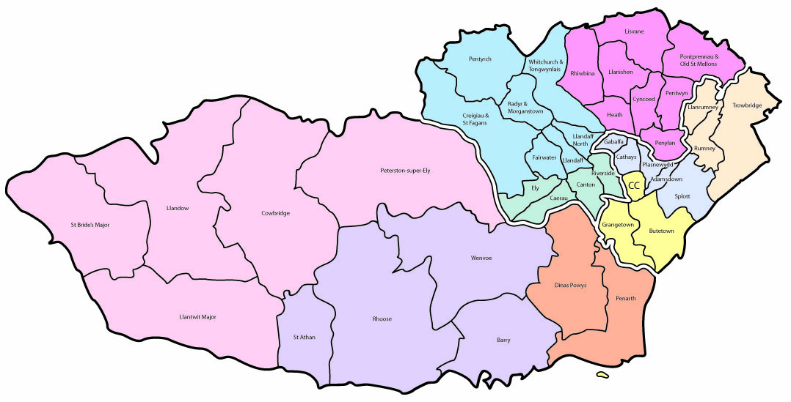
Cardiff South & East Locality

Vale of Glamorgan Locality
Cardiff South West Cluster

So…….the Shaping Our Future Wellbeing: In the Community Programme will provide the major physical infrastructure required to support improved access to health and wellbeing services and assets, ultimately reducing health inequalities.

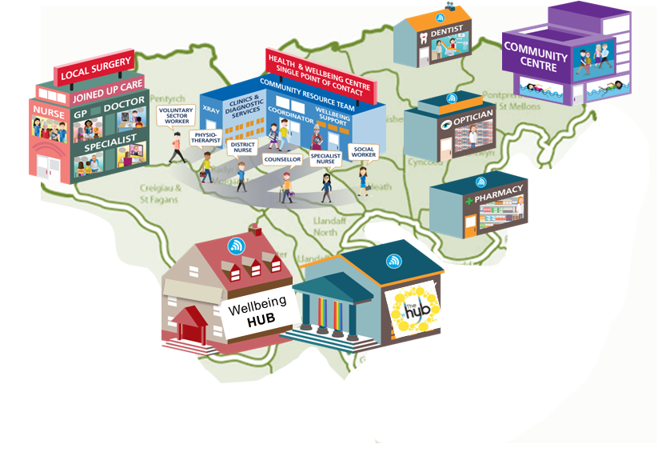
It will consider all assets in each Locality

3. Workshop discussions

To answer the three workshop questions, people were split into two groups, asked to consider the same three questions and then feed back to the group. The questions related specifically to the Cardiff South & East Locality. The responses of the groups have been collated under the headings below.

Q1a. What is the Vision for the Locality Health and Wellbeing Centre?

The two groups covered similar ground but came to different conclusions!

Group 1
“To empower people to live healthy lives by providing appropriate, cultural resources, knowledge and skills, in a welcoming environment.”

Group 2
“CRI: Come Right In!”

Q1b. What are the key health and wellbeing services linked to the wider determinants of health for Locality residents?

The Locality’s priorities linked to the wider determinants of health are:
- Increase participation rates in physical activity;
- Reduce unhealthy eating;
- Reduce number of adults who are overweight or obese;
- Reduce smoking and alcohol misuse.

Both groups’ comments are summarised below:

Key Health and Wellbeing services for Locality residents are:
- Develop a physical activity strategy

- Increase group education classes

- A comprehensive service of wellbeing opportunities accessible to all

Other Services

- Opportunity to support the community to link with other services
- 3rd sector “Taser sessions”
- Family Planning and Department of Sexual Health
- Audiology
- Mental Health
- Ear, Nose and Throat
- Ophthalmology.

How

- Increased multi-lingual and multo-cultyral awareness  - Dementoia friendly  - Meet the chalenges of the wide demography  - Build a “CRI culture”  - Reducing barriers  - Open access outside of core hours  - Introduce technology solutions (e.g. translations) | - Seek Out and reduce barriers  - Look for opportunities for heart screening  - Build relationships  - Clear sighnposting that is ethically and culturally aware  - Wellbeing is the key to delivering services  - Recognising the population trends
Q2. Where are the services identified above best, and most efficiently, delivered?

The groups’ comments are summarised below:

At Home

- Frailty Nurses
- Wellbeing Advice
- Community Resource Team
- District Nurses
- Virtual; Clinics

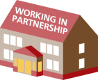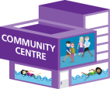
Non-health Community Setting

- Links with University Welfare Services
- C-Card
- Family Planning
- Wellbeing Advice


Primary care (clinical focus)

- C-Card
- Podiatry
- 3rd Sector pre-engagement
- Acute Care Centre for GPs
- Wellbeing advice

Wellbeing Hub
- C-Card
- Local volunteering
- Group education and session work
- 3rd Sector (e.g. Deaf Alliance and Action on Hearing Loss)
- Local Authority advice services
- Café
- Sexual Health
- Audiology
- Podiarty
- Children’s Services
- Retinal Screening
- Therapy Services
- Primary and Sceodndary Care integration
- Flexible counselling rooms
- Wellbeing advice

Health & Wellbeing Centre
As per a Wellbeing Hub for the cluster with the addition of:
- Future proofing with flexibility to change input over time
- Podiatry - diabetic foot disease
- Maternal Health and new-born screening
- Walk-In Centre
- Dental Services
- Optometry
- Muscular-Skeletal (MSK)
- Volunteer navigators (multi-lingual)
- Audiology for adults and paediatrics
- Dementia Services
- Easier access from the whole locality
- Virtual clinics

4. Summary of the process

5. Summary of the process
The workshop demonstrated:

6. Key Actions


- Develop a detailed CRI Master Plan.
- Establish the Programme and Projects Structure.
- Identify the current Service Scope.
- Complete Clinical Output Specifications for proposed services.
- Establish the stakeholder strategy.
- Establish the communication plan
- Develop clinical pathways

7. In the Community Partnership Planning Event,
Cardiff Royal Infirmary. 29 March 2017

Attendance

NAME | ORGANISATION
Sue Toner | Principle Health Promotion Specialist, Public Health Wales
Ros Baker | Team Leader, Cardiff City Council
Alex Gray | Neighbourhood Partnership Officer
Nicki Feneck | Cardiff City Council
Vicci Page | Department of Sexual Health
Sarah Davies | Cardiff & Vale UHB
Adrian Broad | Superindendent Physiotherapist
Denis Williams | ENT Directorate Manager
Wendy Rabaiotti | Head of Audiology
David Meades | Community Director South & East Locality
Haydn Mayo | Community Director North & West Locality
Steph Maidment | Primary Care Support Manager
Eleri Crudgington | Assistant Locality Manager
Helen Nicholls | Community Dietetic Lead, Riverside Health Centre
Jeff Clarke | Lead MSK Podiatrist
Karen Elcock | South and East Cardiff Locaility Manager
Alex Evans | Service Planning Project Lead
Anne Wei | Strategic Partnership and Planning Manager
Clare Williams | Corporate Strategic Planning Lead
Rob Wilkinson | SOFW Programme Support Manager

