APPENDIX 11 Low trauma fractures and Osteoporosis

Low trauma fractures
- Low trauma fractures are identified in men and women aged 50 years and over from standing height or below.
- They are not related to trauma such as a road traffic accident. However, many people with osteoporosis also suffer high trauma fractures.
- Usually bones are strong enough to withstand a fall from standing height or below without fracturing, but if the person has osteoporosis, the bone is more likely to break.
- Typical sites are vertebral; neck of femur and Colles (wrist) but humerus, pelvis and femur are also relatively common.
- Significant height loss, curved spine and back pain may signify vertebral fracture.

Osteoporosis
- Osteoporosis occurs when there is a deterioration of bone, until it becomes so porous that it can break very easily. The bones have a low mineral density.
- 1 in 2 women and 1 in 5 men over the age of 50 will sustain a fracture, as a result of osteoporosis.
- There is a genetic risk and Black African races have denser bones than Caucasian women.
- Bone density is lost during menopause.
- The risk of developing osteoporosis increases with:
  - alcohol use and smoking
  - eating disorders (anorexia or poor nutritional intake)
  - Crohn’s or Coeliac disease
  - corticosteroid therapy; hyperthyroidism and hyperparathyroidism.

Fracture Neck of Femur
Neck of femur of a 23 year old Neck of femur of an 82 year old
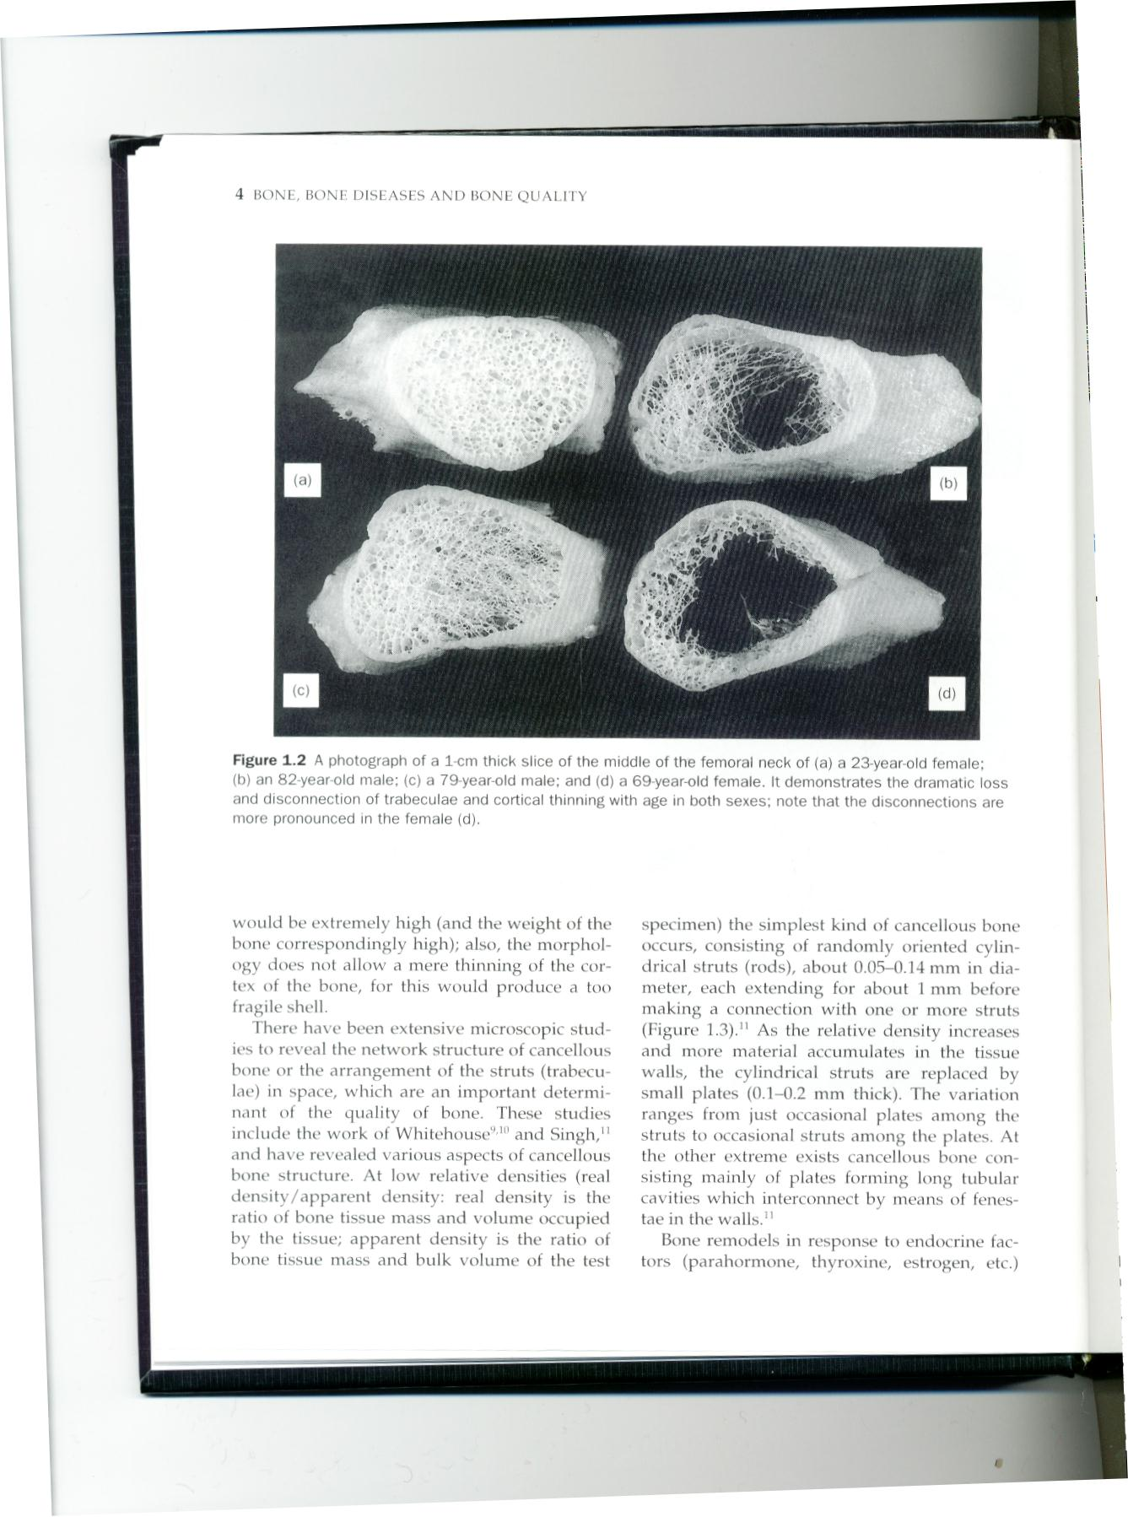

- Fracture neck of femur carries a significant risk of morbidity and mortality. There is a high cost in human terms – 50% do not regain former level of independence and high service costs for health and social care.

DXA Scan
- The diagnosis of osteoporosis is made by a DXA scan (painless x-ray procedure) and to identify individuals most likely to have osteoporosis, there is an aim to scan:
  - All fragility fractures
  - Family history
  - Steroid use
  - Post-menopausal women
  - Kyphosis and loss of height

- Records density of bone at hip or wrist and lumbar spine
- Allows instant assessment of vertebrae

Treatment
- Calcium and Vitamin D supplementation (taken daily)
- Vitamin D alone
- Tablets which can be chewed:
  - Calcichew D3 Forte, Adcal D3, Calceos
- Tablets which can be swallowed:
  - Calcichew D3 caplets
- Soluble tablets:
  - Cacit D3, Adcal D3 dissolve
- Vitamin D alone (dosing frequency varies
  - Colecalciferol, ergocalciferol

- Colecalciferol, ergocalciferol
- Oral Bisphonates:
  - Weekly tablets: Alendronic Acid (Fosamax) and Risedronate (Actonel)
  - Monthly tablets: Ibandronate (Bonviva)
- All should be swallowed whole after an overnight fast with a glass of tap water. After does, person should sit or stand for at least 30 minutes before eating or drinking.

- There are other medication treatments including intravenous therapies.
- Nurses should support patient concordance.

Lifestyle issues
- Patients with osteoporosis should be encouraged to have a moderate alcohol use, stop smoking and take regular weight-bearing exercise.
- A good diet that contains calcium is important.

