STANCE
Diabetes Foot Health Engagement and Empowerment to Self-care

This is a patient resource pack for people who have diabetes. If you would like to attend the STANCE face to face group session, please ask your GP Practice Nurse or contact Education Programme for Patients Cymru.

https://www.wales.nhs.uk/sites3/home.cfm?orgid=537

.


Healthy Me, My Healthy Feet
Foot Health Education for people with Diabetes





We hope you will find this education session enjoyable, useful and informative. The session has been co-developed in partnership with:
- Our patients, Diabetes UK and EPP

It is supported by the Welsh Government advisory Group: The Bevan Commission, Cardiff and Vale Health Board, and the Podiatry Department

Chart 1

We know that looking after your feet when you have diabetes is very important. But, we also know that YOU ARE the most important person in preventing long term complications to your feet from diabetes.

This session has been developed to start to give you the information you need to help you achieve your healthy feet.

Chart 2
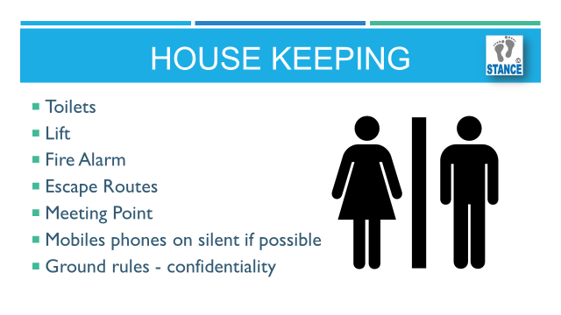
You are here because you have diabetes and we would like to give you the chance to learn more about how it affects your feet, and what you can do to reduce the chance of diabetic foot disease.

Chart 3
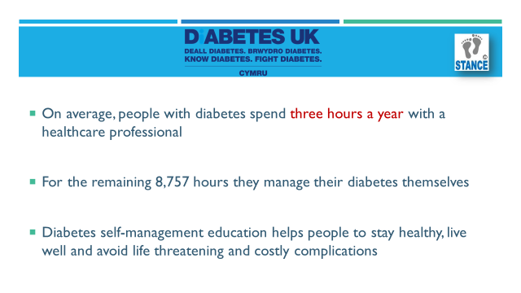
This is about helping YOU look after YOUR feet. Three hours isn’t a very long time to know how and what you can do to look after your Diabetes and everything it can affect, including your feet, eyes, kidneys and heart.
With this in mind take a few minutes to think about what you would like to know about diabetes and your feet.

What are your concerns about diabetes and your feet? | Are you worried about your feet?

Chart 4
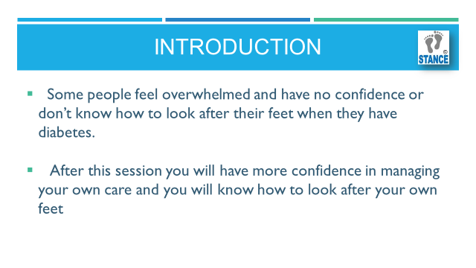
What are the benefits to you if you look after your own feet?
So this is the difference between people who are involved, engaged and participating in their own foot health and care.

Chart 5
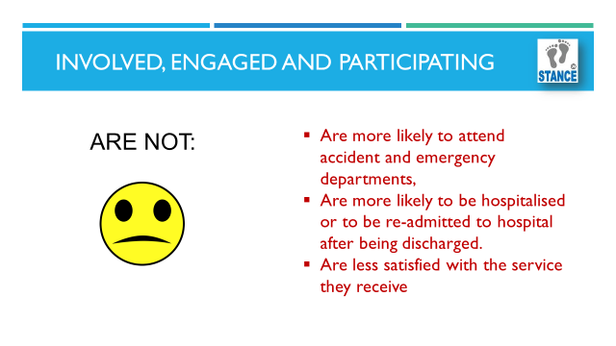
Chart 6

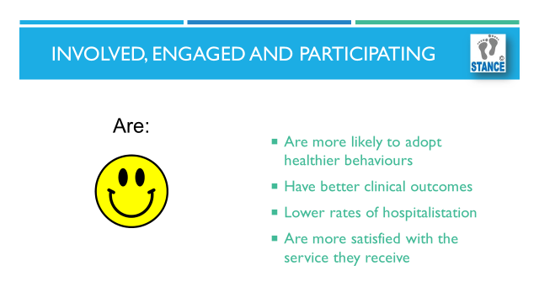
Simply, the fact that you are here in the first place and taking part in the session means you want to be involved with your health and that is a very positive step. Let’s get things put in place now to help prevent problems in the future.
We’ll move on now to think a little bit about what exactly diabetes is.
Chart 7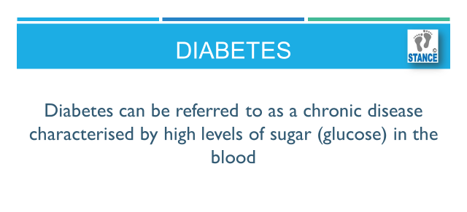
There are a number of different types of diabetes and a number of different reasons why some-one may get diabetes but there are 2 main types.

Chart 8
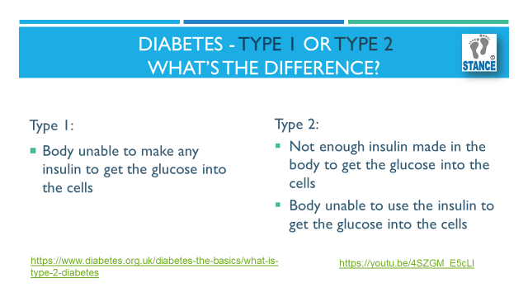
As far as Diabetic Foot Disease is concerned it does not matter which type you have. If your blood sugar is high the effects on your body are exactly the same.
Now for some straight talking. We want to tell you some facts about what diabetes can do to your body if it is not managed properly.
Chart 9
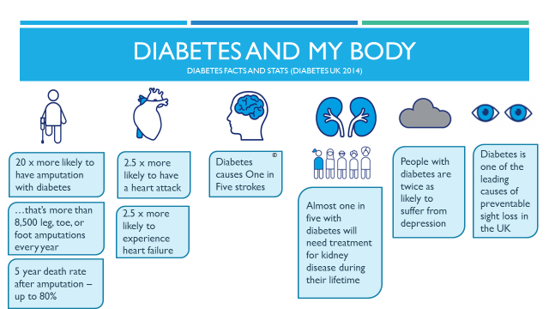

How do you feel about this information, does it make you feel concerned or anxious?
Lots of things are in place to help you prevent these problems from happening. There is a leaflet in your resource pack which states the 15 annual checks you may need when you have diabetes.
These include your annual foot checks.
There are many simple things that you can do to help reduce the risk of the complications we have just looked at.
One very important skill is to get as much information about your condition as you can.
We will take you through 4 key messages which will help you reduce the risk of ulceration and amputation to your feet.

Chart 10
Let’s look at the 4 key messages in more detail
Chart 11
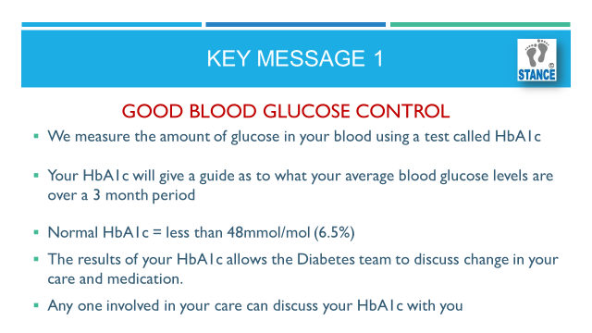
There is a conversion chart in your resource pack, if you prefer the % values rather than the mmol/mol to review your HbA1c?
What can happen if we DON’T have good glucose control?
We will start with Poor Circulation, also known as Peripheral Arterial Disease or PAD.

Chart 12
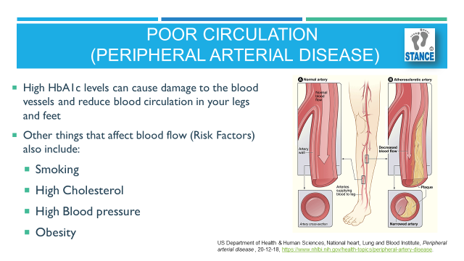
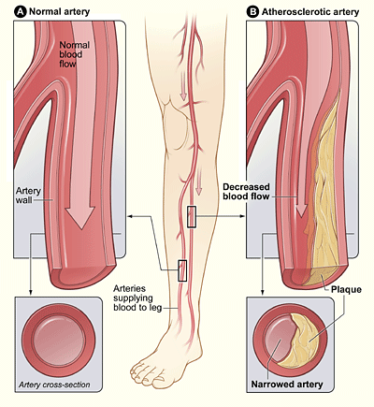

These risk factors are very important when you have diabetes.
They can contribute to the damage of your blood vessels and make things like stroke, heart disease, kidney disease and toe and foot amputation more likely.
The trouble with PAD is that you may not experience any symptoms with it. That is why you have your circulation tested once per year.

Next is Nerve Damage
Chart 13 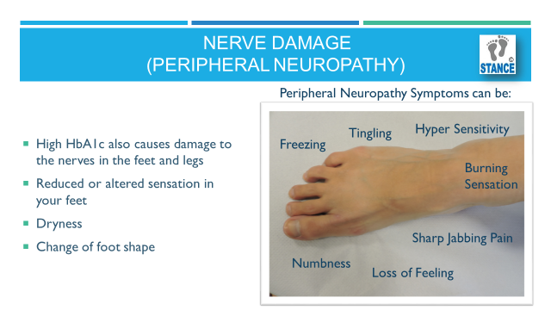
Some of you may have experienced these symptoms. We often hear people describe a loss of feeling, numbness, sharp jabbing pain, burning sensation, tingling, freezing, or a hyper sensitivity where even the lightest of touch is painful.

These sensations can improve with good blood glucose management.
The trouble with the loss of feeling is that you may not feel when you damage your foot. You may have a cut or a blister that you are not aware of, which could become infected if not looked after.
Once there is a loss of feeling, this sensation will not return.
This is why it is very important to check your feet daily or more often if you are doing more walking, wearing a different pair of shoes, on holiday or if your feet are swollen.
To summarise, Foot Complications in people who have diabetes are more likely to occur in people who have an ongoing high HbA1c or high blood glucose/poor control.

Chart 14
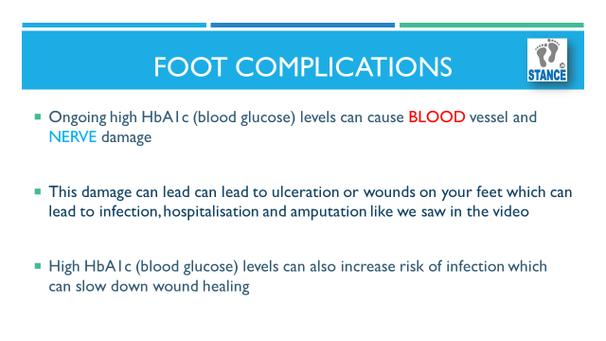

Now let’s look at Key Message 2
Chart 15
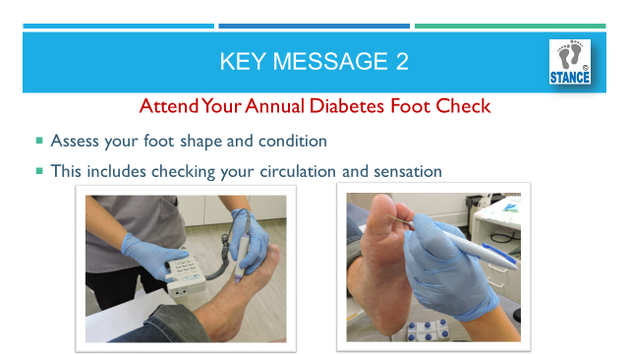
Your foot risk classification will be one of the following categories - that’s the risk of you getting a foot ulcer because of your diabetes.

Chart 16
If you have a risk classification of low, this means that your circulation and touch sensation are normal and you will be reviewed at your GP Surgery annually.
If you have a risk classification of Moderate or High you will be referred to the Podiatry team for further assessment.
If you have an Ulcer on your feet that means you have Active foot disease and you will be referred urgently to the podiatry wound care team. That means you should have an appointment within 24 hours of your referral (although podiatry is not a 24/7 service).

Now let’s look at Key Message 3. Regular foot care DO’S.
Chart 17
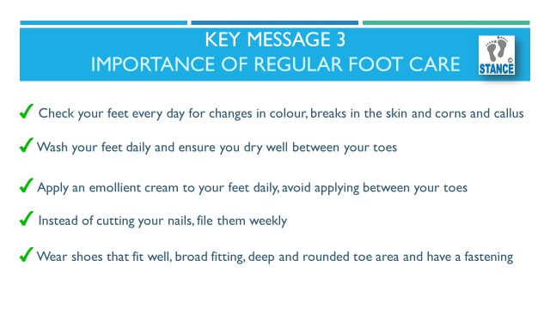
You can buy foot cream in your local pharmacy or supermarket. Ideally foot cream should contain UREA - it will say this on the ingredients.
Avoid putting the cream between your toes, as this can make the skin soggy and lead to a fungal infection.
Filing is a great way of managing your nails without worrying about doing damage to the skin around the nail. You can use an emery board or a metal diamond deb file which are available in chemists.

There is a footwear advice leaflet is available in your resource pack.

These are the Regular foot care DONT’S

Chart 18
Blades and corn plasters can damage the skin, avoid using any sharp instrument that could break the skin and lead to infection. Some people like to use a nail brush or an old toothbrush to keep the side of their nails clean.
Ensuring you have slippers or shoes on all of the time can help protect your feet from any sharp objects of knocking your toes.

Finally we have Key Message 4.
This is a very important message and is about you getting help at the right time and when you need it. You can get advice from your Pharmacist, Nurse, Health Care Support Worker, Doctor, Private Podiatrist or NHS Podiatrist.

Chart 19
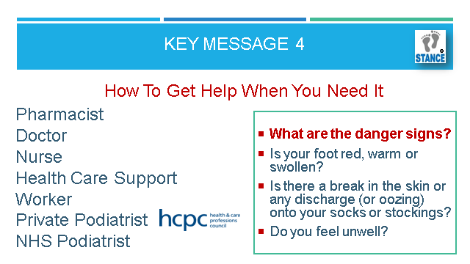

You should do this urgently if you have a red, warm swollen foot, if there is a break in the skin or any discharge (or oozing) or if you feel unwell.

If you use a Private Podiatrist, you should check they are qualified to provide Podiatry treatment and advice. Often the Health & Care Professions Council (HCPC) logo will be on their advert or you can check on the online HCPC register.

There is a leaflet in your pack explaining this.
Now we will take a look at how diabetes affects our feet. WARNING, the next slide contains images of foot wounds so please be prepared, but it’s important to know what you are looking for or even better, trying to stop.

Chart 20
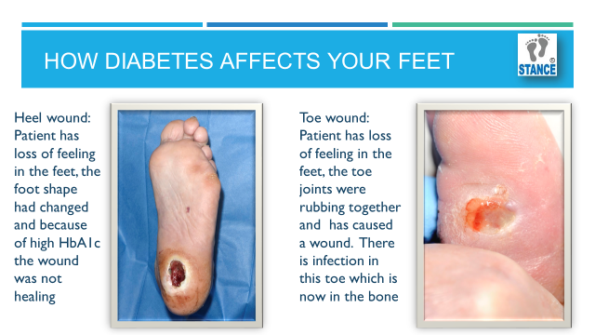

It’s important to remember that it’s not just about looking after your feet daily that can help prevent wounds like this.

It is really important to keep your blood glucose levels within target range and take the following steps to help prevent problems.

Chart 21
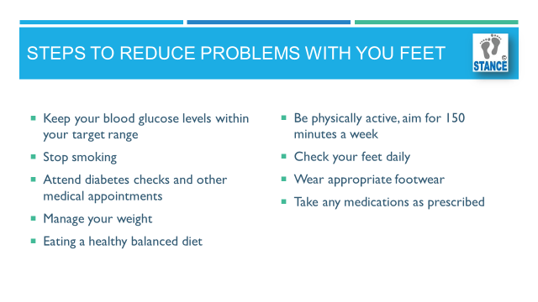
Help me quit is a group which provide support to help you stop smoking.
There are courses to go on to help you manage your health and well-being in your area and you have further information in your resource pack.
There are lots of ways to exercise without having to go to the gym. Walking to the post box, housework or the shop can be included in this time.
Remember you can have a medication review with your local pharmacist free of charge. You should speak to your doctor or pharmacist before stopping any medication that has been prescribed.

I’d like to introduce you to an information resource called Pocket Medic. It can be accessed from your phone or computer to view many different short films about diabetes.
You don’t have to sign up or make an account which often puts people off. You can just type the address straight into your phone, iPad, laptop or computer to watch the films.
There is a leaflet in your resource pack showing you how to access the films.
The films are only about 5 minutes long and you can watch which ever you like.

Chart 22
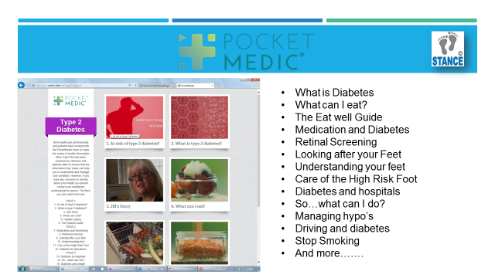

People who spend time watching these films learn valuable information that helps them reduce their HbA1c and reduce their risk of getting diabetes complications.

Chart 23
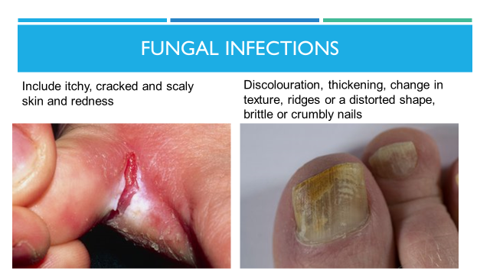

Athlete's foot is a common fungal infection of the skin on the feet. The conditions fungi like best are warm, moist and airless areas of skin, such as between the toes. However it is common for the soles of the feet to become infected too.
Athlete's foot can also be passed on from person to person. For example, this may occur in communal showers used by athletes or swimmers. It may make the skin itchy and flaky and pinky-red in appearance.

How do I treat Athletes Foot?
· Buy an antifungal cream from pharmacies or supermarkets. There are various types and brands available in various strengths. Ask your pharmacist for advice on the best cream for you
· Apply the cream all over both feet (even if just one is affected) using sparingly between the toes
· Continue for 1-2 weeks after the infection has cleared to avoid reoccurrence
The following tips may prevent Athlete's Foot recurring
· Wash your feet daily and dry the skin between your toes thoroughly after washing. It is tempting to put socks on when your feet are not quite dry. The soggy skin between the toes is then ideal for fungi to grow.
· Do not share towels. Wash towels frequently.
· Change your socks daily. Fungi may multiply in flakes of skin in unwashed socks. Cotton socks and leather footwear are probably better than nylon socks and plastic footwear which increase sweating.
· Where possible alternate between different shoes every 2-3 days to allow each pair to dry out fully after being worn.
· Wear flip-flops or plastic sandals in communal changing rooms and showers. This prevents the soles of your feet coming into contact with the ground, which may contain flakes of skin from other people.

Chart 24
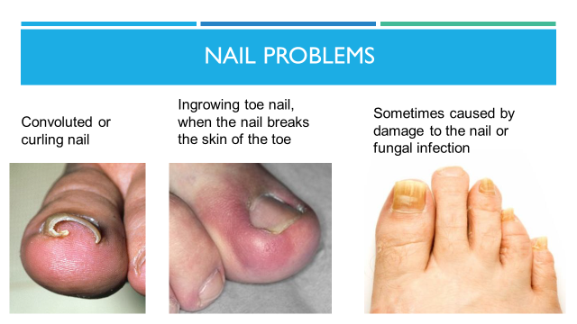

Cutting and filing toe nails

Filing toe nails is best, however:

How do I cut my toe nails safely?
Ensure that you have the right tools for the job before starting to cut your toenails. Podiatrists use nail ‘nippers’ which can be purchased in most chemists or supermarkets.

· Try to cut your nails following the natural curve of the toe.
· Do not cut your nails too short- a small crescent of nail should still be visible at the end of your nails after cutting them
· Do not cut or poke anything down the side of the toe.
· Use a soft nail brush to keep your nails clean

How do I file my toe nails safely?

Often filing nails regularly can keep them to a manageable length

· Use a good quality nail file
(‘Diamond Debs’ are commonly used in the Podiatry Clinic)

· Hold the file over the nail and pull it gently away from you

· Do not file the nails too close to the skin

· Carry this out 1-2 times weekly to keep nails manageable

Chart 25
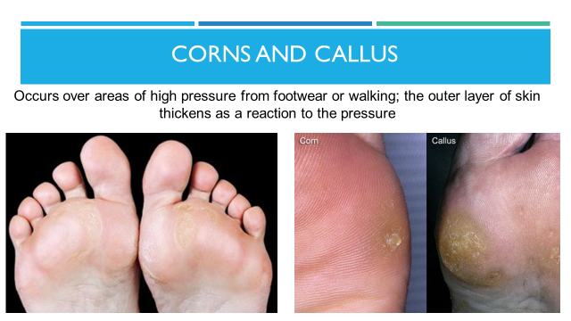

Chart 26
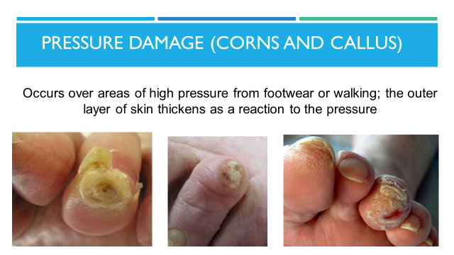

Corns and calluses on the feet are thickened areas of skin that can become painful. They are caused by excessive pressure or rubbing (friction) on the skin.
The most common causes are:
· Poorly fitting shoes- your foot shape not coinciding with the shape of the shoe/slipper causing rubbing
· Your foot function
· Prominent joints in your feet
Advice
Follow the advice from your Podiatrist regarding your footwear. Check that your shoes are not too tight or too loose and that they are the right shape for your feet.
Apply a moisturising cream daily and gently rub area with a pumice stone or foot file. Urea based creams are most effective for this.
Cushioned insoles may help.
Never use razors or sharp instruments to remove the skin. Do not wrap material around the toes, which can become uncomfortable and tight.

Chart 27
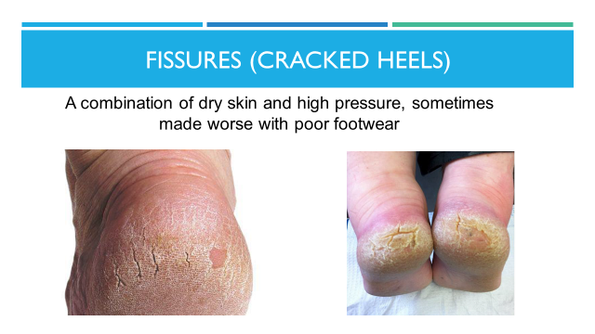

Cracked Heels (Heel fissures)
Heel fissures are splits or cracks in the skin which appears around the heel. They usually occur if you have dry and hard skin and often wear open backless or slip-on footwear. The area can become very sore if you pick it or use a sharp instrument. Sometimes the area can bleed or become infected.

Advice
Avoid slip-on shoes and wear closed back footwear (this should include your slippers if you wear them)
Never use razors or sharp instruments to remove the skin. A pumice stone or foot file is best suited for reducing dry skin on the heel area
Cream your feet and heels daily; Urea based creams are often the most effective.

Chart 28
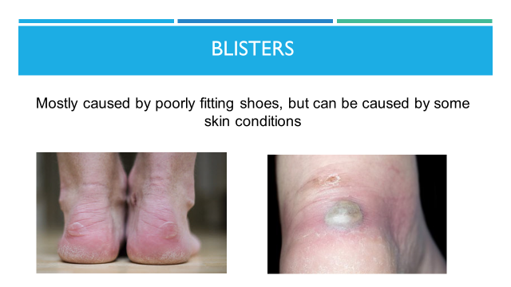
How you can treat a blister yourself
To relieve any pain, use an ice pack (or a bag of frozen vegetables wrapped in a towel) on the blister for up to 30 minutes.

To protect the blister and help prevent infection:

Do: Cover blisters that are likely to burst with a soft plaster or dressing
Wash your hands before touching a burst blister
Allow the fluid in a burst blister to drain before covering it with a plaster or dressing

Don't: Do not burst a blister yourself or peel the skin off a burst blister
Do not pick at the edges of the remaining skin
Do not wear the shoes or use the equipment that caused your blister
If the blister is infected it can be red, hot and filled with green or yellow pus. Ensure you get advice from your GP or local podiatrist.

If you regularly get friction blisters: Wear comfortable, well-fitting shoes
Wear thicker wool socks during exercise
Dust talcum powder in your socks if you get sweaty feet

Chart 29
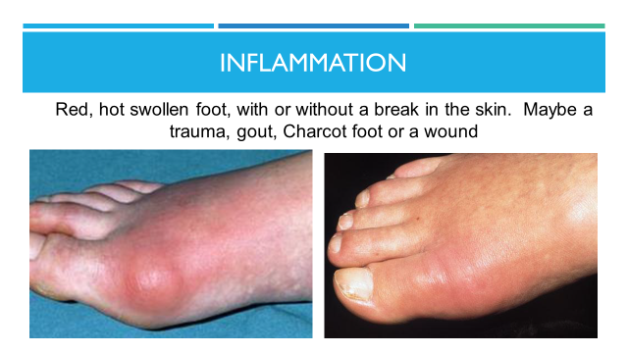

Charcot foot occurs in people who have peripheral neuropathy such as people with diabetes. It is where the bones become soft and start to collapse making the foot change shape rapidly, the foot is normal red, hot and swollen usually with no break in the skin. This is not life threatening but is a medical emergency and the patient should seek help immediately for advice.

Chart 30
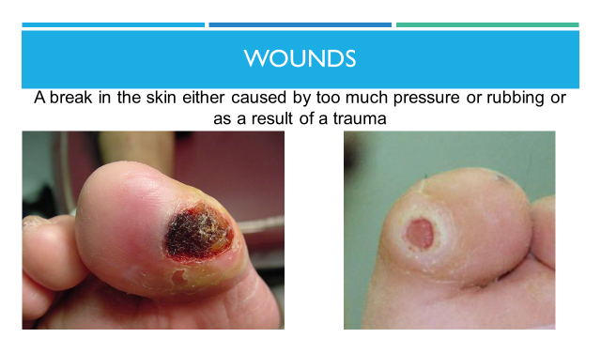
Wounds may occur as the patient does not feel the damage happening to their feet. Cover them with a clean dressing as soon as you spot them. Both of these are wounds and need professional help immediately. Cardiff and Vale Podiatry Wound team number is 02920 335135 or 02920 335134
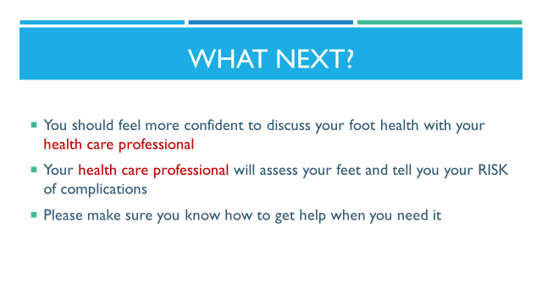
Chart 31

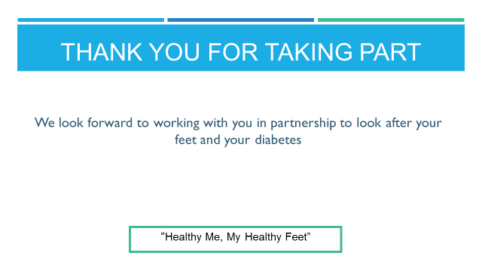

If you have any questions, please speak to a health care professional
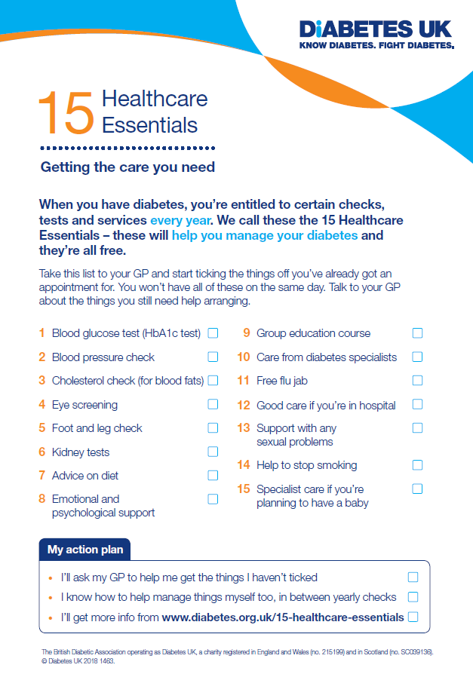


Footwear Fitting Advice
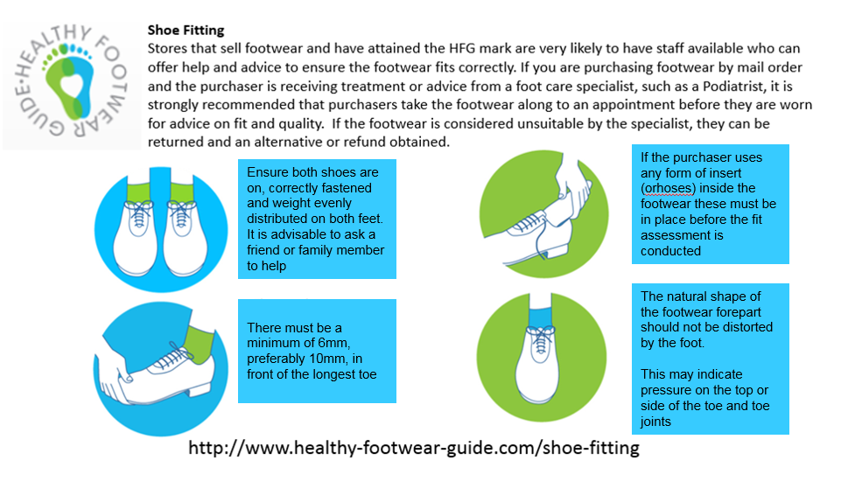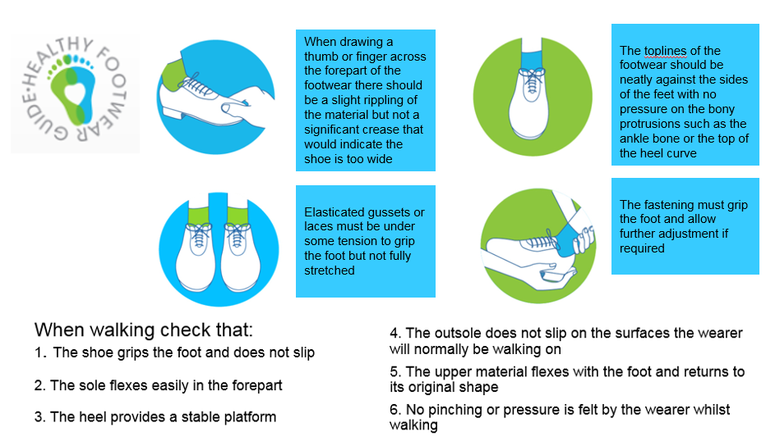
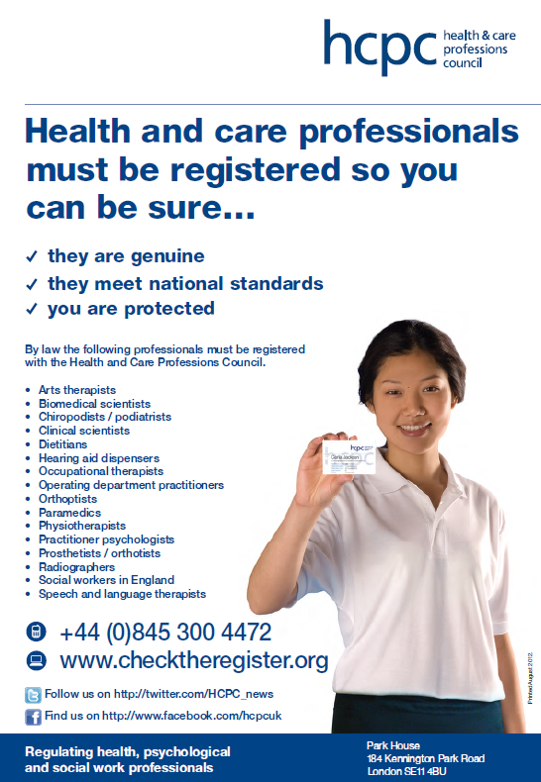

Help me Quit

