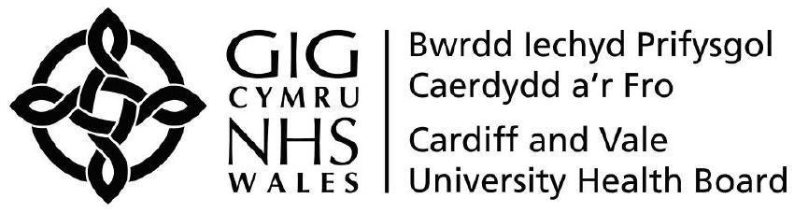
Cardiff and Vale University Health Board - Declaration of Outside Work
Section 1
In addition to your work with Cardiff and Vale UHB, do you undertake work outside of the UHB e.g. paid work / voluntary work? | YES  NO

Should you undertake any outside work during your employment with the Cardiff and Vale UHB you must declare the details to your Line Manager and complete this form:

Employment Details
Name:
Job Title:
Band / Payscale:
Department:
Telephone contact details:
Hours worked per week with Cardiff and Vale UHB:
Please outline your work pattern within Cardiff and Vale UHB (e.g. days worked, shift pattern):
Other Employers Name:
Nature / Type of Business:
Number of hours worked per week in other employment:
Please outline your work pattern in other employment (e.g. days worked, shift pattern):
Will you be working more than 48 hours per week in total or more than 12 hours in any one 24 hour period as a result of your combined employment? |  |  |  | YES  NO
Any other relevant information you wish to disclose:
N.B. if applicable please also complete the Working Time Regulations Opt Out Form

Section 2 – Declaration & Authorisation
To be completed by Employee
Name:
Signature:
Date:
To be completed by Line Manager
Do you envisage a conflict of interest between “outside work” and the employee’s employment with Cardiff and Vale UHB? |  | YES  NO
Name:
Job Title:
Signature:
Date:

