GUIDANCE FOR
PATIENTS, PARENTS AND CARERS WHEN ATTENDING A FACE TO FACE APPOINTMENT

YOU can make a REAL difference in the fight against the coronavirus spread by following these guidelines when attending an appointment.

BEFORE YOU ATTEND

Please let us know by telephoning the service if you or your child are feeling unwell and have any of the following symptoms:
- A persistent cough (one that won’t go away!)
- A High Temperature (over 37.8 C)
- Difficulty in breathing (feeling out of breath)
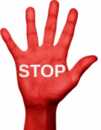
- Loss of taste or smell
DO NOT ATTEND IF YOU OR A FAMILY MEMBER WITHIN THE HOUSEHOLD HAVE ANY OF THESE SYMPTOMS.
ATTENDING THE APPOINTMENT

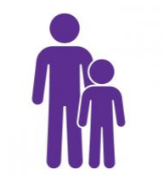 | To adhere to social distancing requirements we ask that only 1 parent or carer attend the appointment with the child / young person and no siblings please.
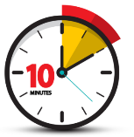 | Please do not arrive any earlier than 10 minutes before the appointment time.
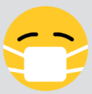 | Face coverings must be worn at all times in public unless you are medically exempt. Children aged 10 years and under do not need to wear a face covering.
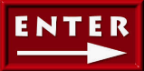 | Follow the arrow markings on the floor, keeping to the 2 metre social distancing rule.
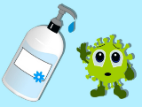 | Please use the hand sanitisers that are placed throughout the building. Please note that there are now dedicated toilets for staff and patients and we ask that you wash your hands and re-sanitise after leaving the facilities.
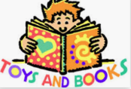 | Due to infection control, we are unfortunately not able to provide toys or activities in waiting areas / clinic rooms so please bring these along with you if you feel necessary.

